**HR Dashboard**

**Introduction**:

The Human Resource dashboard is an important part of managing Human Resources. The tool is part of HR reporting and for the basics of informed decision making. Why? Because it is hard to make informed decisions when [HR business partners](https://www.analyticsinhr.com/blog/hr-business-partner/) and other stakeholders lack insight into their own organization. Never fear, HR reporting can solve this! How? Well, that’s what this project is all about.

**Scope of HR dashboard:**

HR dashboards are useful for analysing performance and identifying areas for improvement in an organization. They’re not only important to HR managers, but for executives as well. Decision makers ensure that company strategy is aligned from executive to managerial to individual goals. Executives and HR leaders must work together to identify the data they need in order to take action. Then you can collect and monitor that data to keep workforce performance aligned with organizational objectives.

**Data set used:**

The data set contains the below data points with the shape of 28 columns & 310 rows of data.

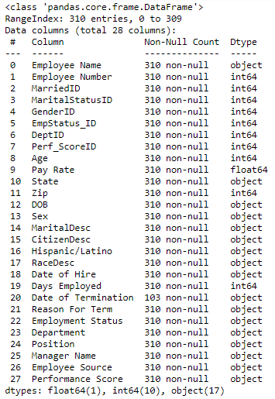

**Technologies used:**

In this project I have made an attempt to create a HR dashboard in **Python** using dash library to get summary numbers for an imaginary organization. The required python packages are

* dash==1.2.0
* dash_table==4.2.0
* pandas==0.24.2
* numpy==1.16.2

The HR dashboard that showed information about recruiting sources, active employees, attrition rates, and many more. With Plotly and Dash, I experimented with chained callbacks to allow for more variety of dashboard filter options.

**Dashboard information:**

The Dashboard four different taps

1. Head Count & Attrition
2. Diversity Profile
3. Recruitment
4. Data Table

**Head Count & Attrition:**

Many companies make significant investments when hiring new employees- There are recruiting costs, training costs, salary, benefits – and the list goes on. In addition, it could take a while until companies start seeing a return on their investment. Hence, companies are constantly looking for ways to reduce employee turnover rate and to prevent valued employees from leaving the company. This tap contains the information of below data points.

* Number of employees (It can be viewed by monthly & yearly wise options)

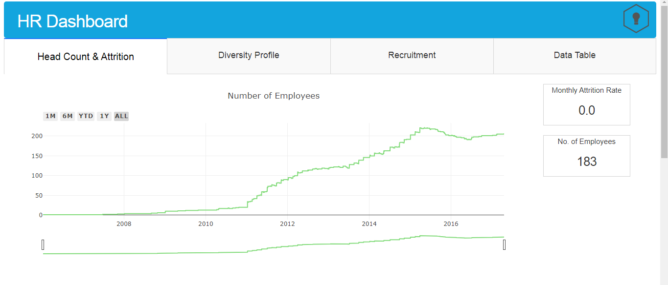

* Attrition rate (Filter by: Department wise)

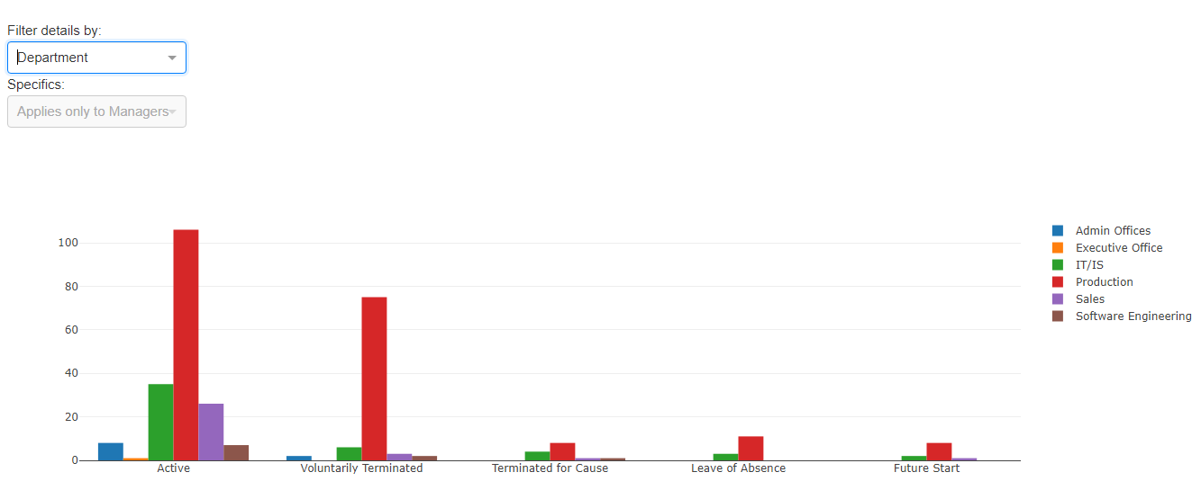

* Attrition rate (Filter by: Position wise)

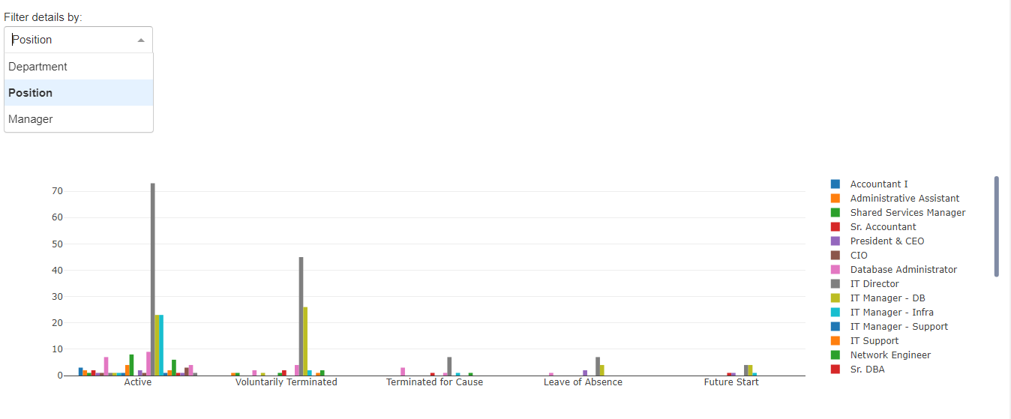

* Attrition rate (Filter by: Manager wise)

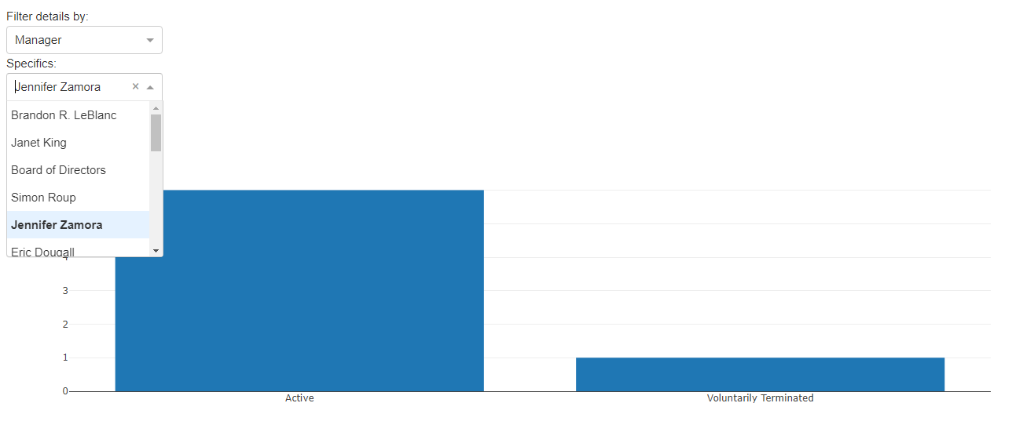

**Diversity Profile**

It’s easy to say that your company is diversified and inclusive. With the recent news of numerous employee diversity and inclusion issues in a lot of industries, companies are becoming increasingly aware of their activities when it comes to hiring. This tap contains the information of below data points.

* Gender by department

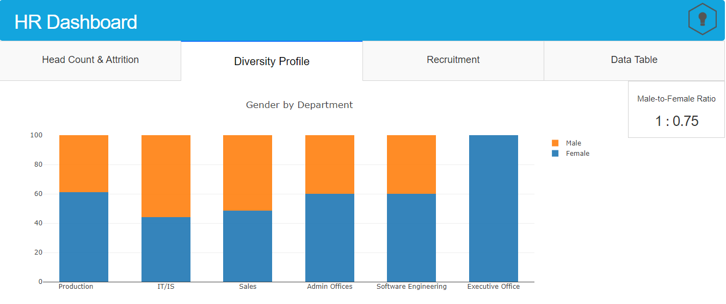

* Race by department

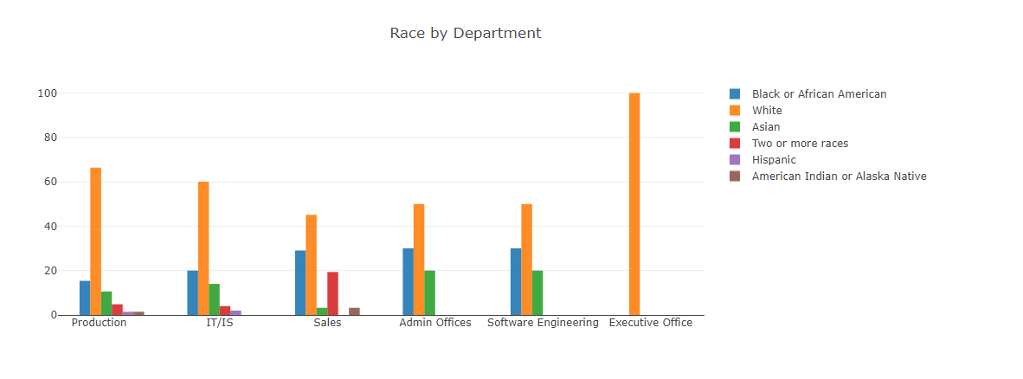

**Recruitment**

Measuring the hiring process can contribute to organizational efforts to reduce the above by getting insights into the process. This will allow the organization to identify areas that it needs to improve\maintain\develop and take action accordingly. This BI solution is meant to identify bottlenecks and opportunities in the hiring process in order to improve efficiency, avoid lost revenue and additional costs by reducing the time it takes for the organization to hire new employees. This tap contains the information of below data points.

* Recruitment source

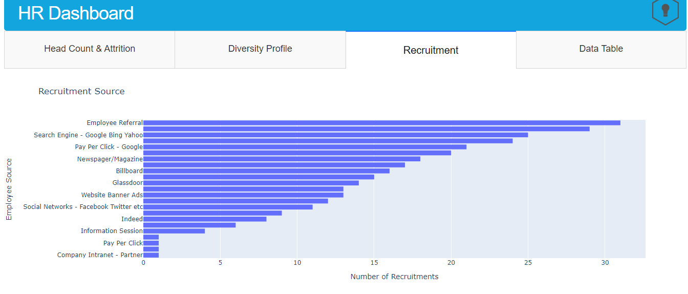

* Recruitment source by department

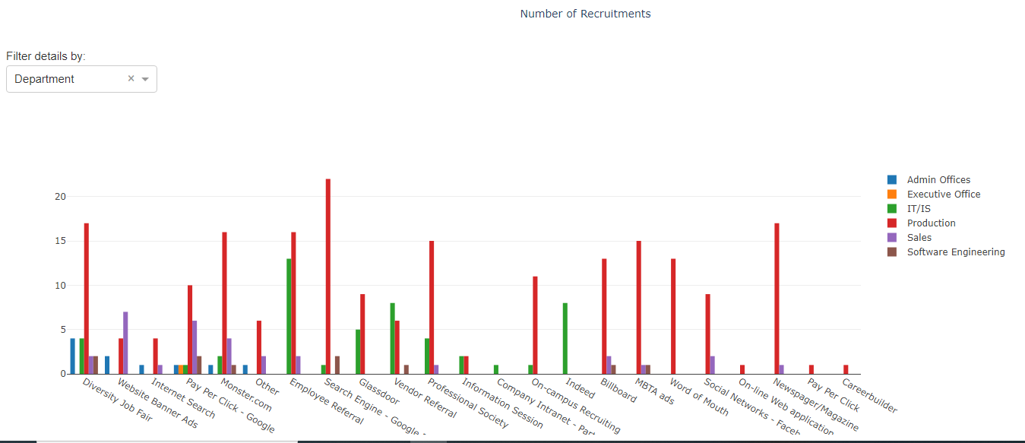

* Recruitment source by State

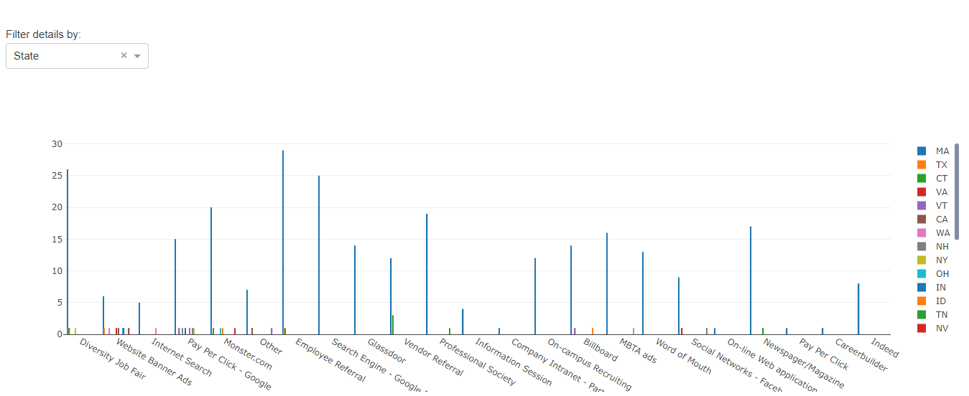

**Data Table**

In this tap you can view the dataset we used for the dashboard.

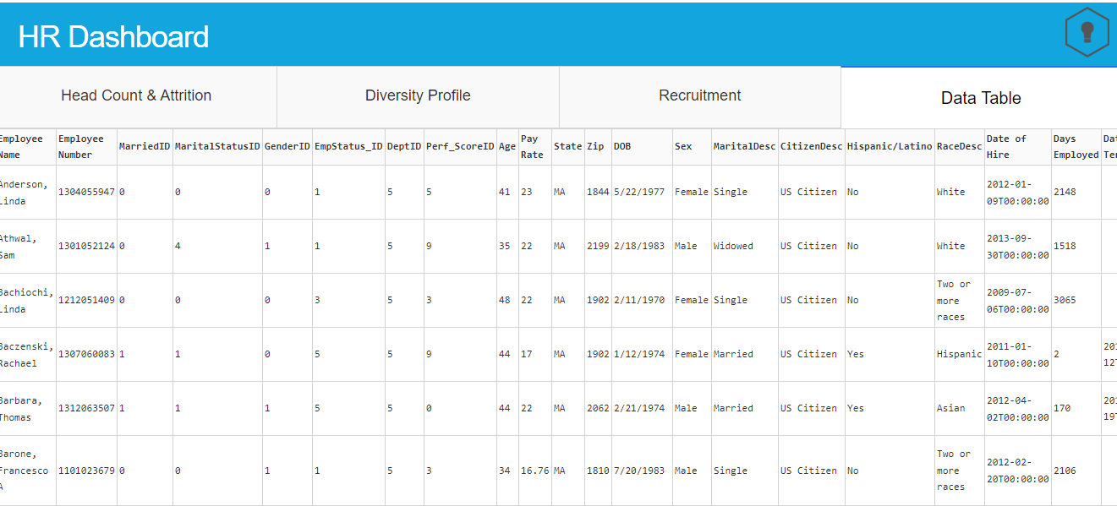

**Data visualization features**

In this dashboard every chart having the different features to see the chart.



The features are

* Download plot as PNG image format
* Zoom in & out
* Pan
* Box Select
* Auto scale
* Reset Axes
* Show the closest data on hover
* Compare the data on hover

**Conclusion**

This project has not been deployed yet, so it can only be run locally. The web app will be launched to your localhost on port 8050: <http://127.0.0.1:8050> . So the data won’t be shared to outside of organization as per data privacy policy.